

**NATIONAL UNIVERSITY OF SCIENCES & TECHNOLOGY**

**SCHOOL OF MECHANICAL AND MANUFACTURING ENGINEERING**

**SEMESTER # 01**

**CLASS: - ME 15 [SEC A]**

**KASHIF NADEEM KAYANI**

**456466**

**Fundamentals of Programming**

**LAB MANUAL 06**

**Date of Submission 22 NOV 2023**

**Submitted to MUHAMMAD AFFAN**

**QUESTION NUMBER 01**

**Generate the Fibonacci sequence using nested loops.**

/*_____________________________________________

Generate the Fibonacci sequence using nested loops.

LAB MANUAL 6 Q#01

KASHIF NADEEM KAYANI 456466 ME-15 SEC A

*/

#include<iostream>

using namespace std;

int main (){

int a,b,n; // declaring 3 variables

a=1; //assigning value a=0.

b=1; //assigning value b=1.

cout<<"enter the number of terms of fibonacci sequence ";

cin>>n;

cout<<a<<" "<<b<<" "; //printing a and b

for ( int i=1;i<n;i++) //using for loop for i

{

for( int j=1;j<i;j++) //using for loop for j.

{

int res=0; //declaring res as a=b.

res=a+b;

cout<<res<<" "; ///printing result [a=b].

a=b;b=res; //rotating variable b and res.

}

} return 0;

}

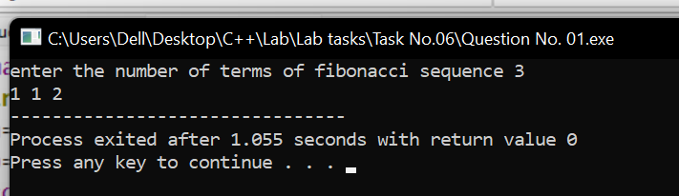

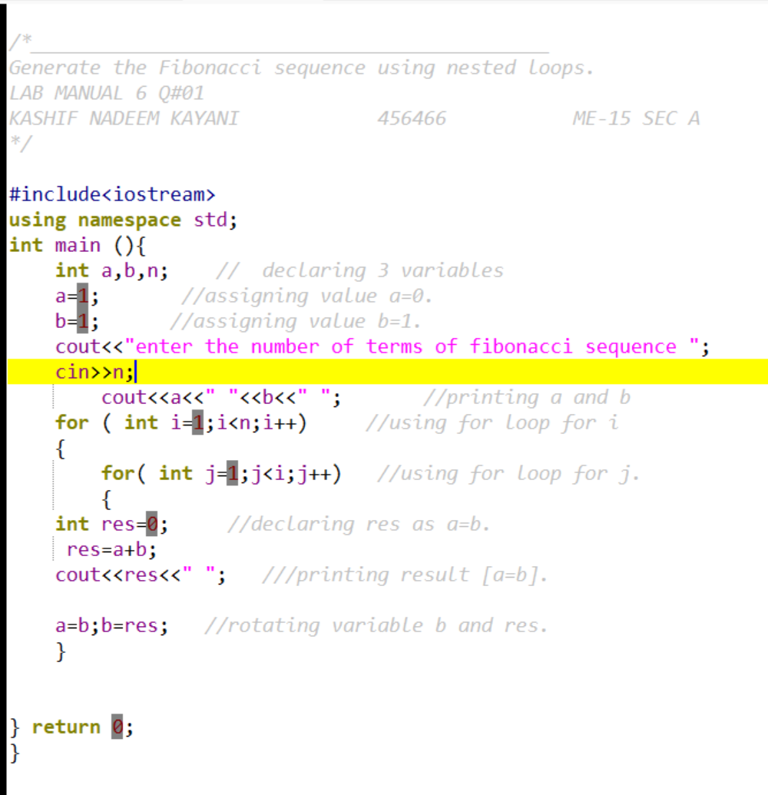

**QUESTION NUMBER 02**

**Create Floyd's Triangle with nested loops.**

/*_____________________________________________

Create Floyd's Triangle with nested loops.

LAB MANUAL 6 Q#02

KASHIF NADEEM KAYANI 456466 ME-15 SEC A

*/

#include<iostream>

using namespace std;

int main()

{

int n; //declaring number of rows

cin>>n; //input from user

int sum=1; //declarong a variable sum.

for (int i=1;i<=n;i++) //using for loop for i

{

for( int j=1; j<=i;j++ ) //using for loop for j.

{

cout<<sum<<" "; //printing sum

sum++;

} cout<<endl; //going to next line

}

return 0;

}

